**Member lists**

* Hana Al-Bidaq
* Majed Amria

**Abstract**

The problem we are looking to solve is the rare data about the skills people in Palestine, we are suffering finding a qualified skilled person to fix an old work, or to start new work. Also to know the education background for this person, and the experience he/ she have, and how other people evaluate this person based on there experience.

From other hand we want to provide the people and the skills person with a list of companies and shops they providing/ selling the tools and equipment’s and materials requested and needed for technical works.

**Requirements**

**ERD**

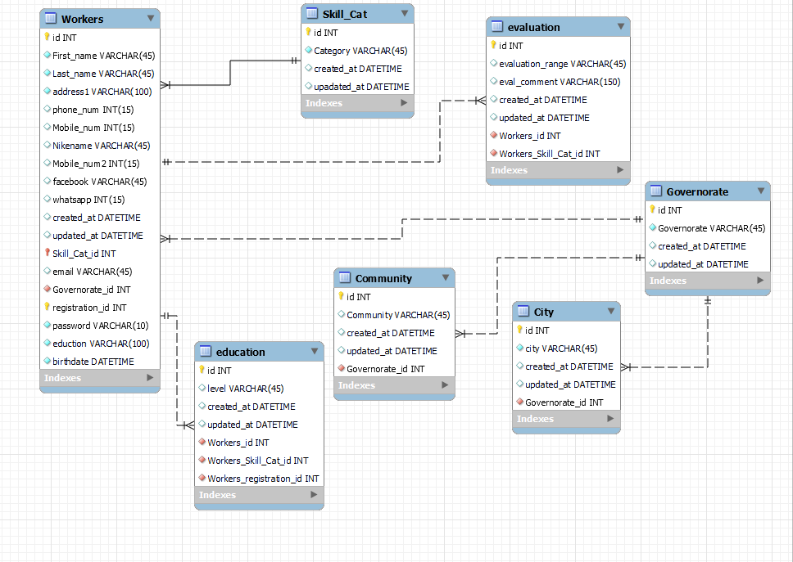

**Wireframe**

